Phonics:  We are learning the new sound/phoneme: air  Watch the DFE video: https://www.youtube.com/watch?v=JoaUENu-9Ck  Read/write these words: air hair pair fair chair lair  Read/write sentences: Is all hair fair? Can a shark sit in a chair? Did they get to the dark lair? | Phonics:  We are learning the new sound/phoneme: ear  Watch the DFE video: https://www.youtube.com/watch?v=WEKPH4TR8nU  Read/write these words: ear dear fear hear gear near tear year rear beard  Read/write sentences: Did the shark feel fear? Can a toad hear? Is the church near the park or the farm? |  | Phonics:  Play games on phonics play:  https://www.phonicsplay.co.uk/  Trash and treasure – sorting real and nonsense words  Try Forest Phonics games: Can you build the words?  http://www.ictgames.com/mobilePage/forestPhonics/index.html | Phonics:  We are revising all the sounds we have previously covered.  Read/write these words:  chair hair hear spear fear fork curl shark horn beep rich cow how  Write these sentences, cut them up and ask the chn to re-order them.  My hair has red paint in it.  I can see a fork on the chair. | Phonics:  We are practicing reading and writing our tricky words.  We are learning the new tricky words: they her all are  See tricky word game: https://epicphonics.com/games/play/free-penalty-shootout-tricky-words-game
Literacy:  Learn/sing the song – 5 little speckled frogs!  Do frogs lay eggs?  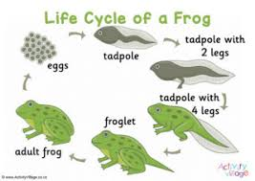  Draw and label the life cycle of a frog. | The World/RE:  Share images of different eggs.  Share some videos of eggs and ask the chn what they think is inside them? https://www.youtube.com/watch?v=FeCzAuLpSqQ  Life cycle of a frog video: https://www.youtube.com/watch?v=F3ElGMVU6SY |  | Home Learning! 22/2/21  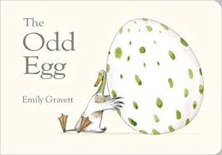  Theme: New Life!  Our main book this half term is ‘The Odd Egg’ https://www.youtube.com/watch?v=8LKoji2i7Cw |  | Literacy:  Write/record/video some sentences/captions or conversation about The Odd Egg.  What is inside it?  What happens to the egg?  Did you enjoy the story? Why?  Why was the crocodile calling the duck ‘Mama’?
Physical Development:  Have a go at some obstacle races in your garden or local park. You can jump, skip and hop. Can you put some obstacles down to jump over? E.g. boxes, teddies etc.  What can you do in 1 minute? Ask a grown up to time you on their phone or watch.  Make some cloud dough - https://tinkerlab.com/cloud-dough-exploration/ |  | WELL-BEING WEDNESDAY  We would like you and your children to focus on your well-being today! Here are a few ideas of things you could do:  - Hand massages and have a foot spa!  - Make friendship bracelets – use wool/thread and add beads or buttons. Great for fine motor skills!  - Learn a new card game - https://www.todaysparent.com/family/activities/10-kid-friendly-card-games/#gallery/kid-friendly-card-games/slide-2  - Try some mindful breathing exercises. https://www.youtube.com/watch?v=DSgOW879jjA |  | 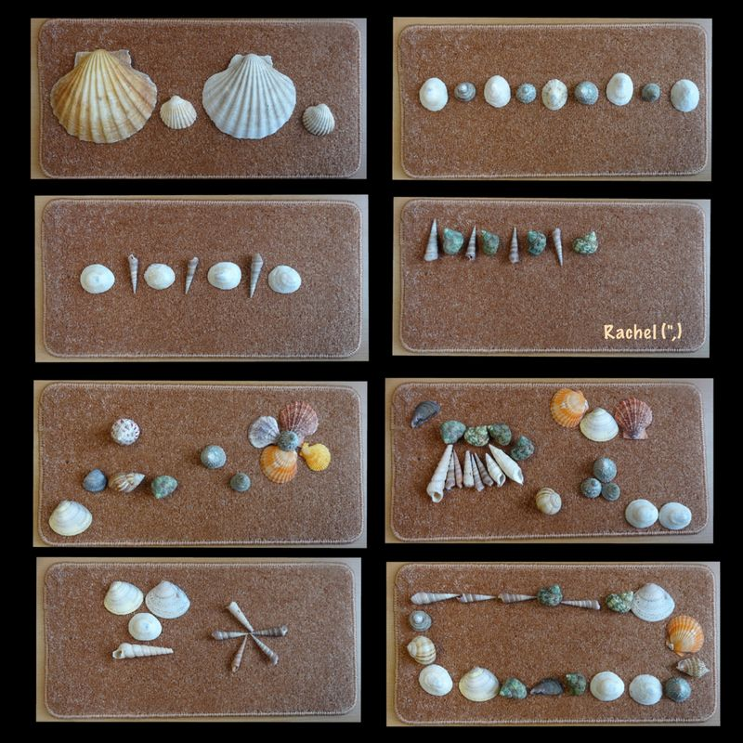  Art and Design:  Make some patterns with natural objects.  Can you complete an ABB pattern? (swirl jump jump swirl jump jump etc.)  Decorate egg shells with your own patterns.  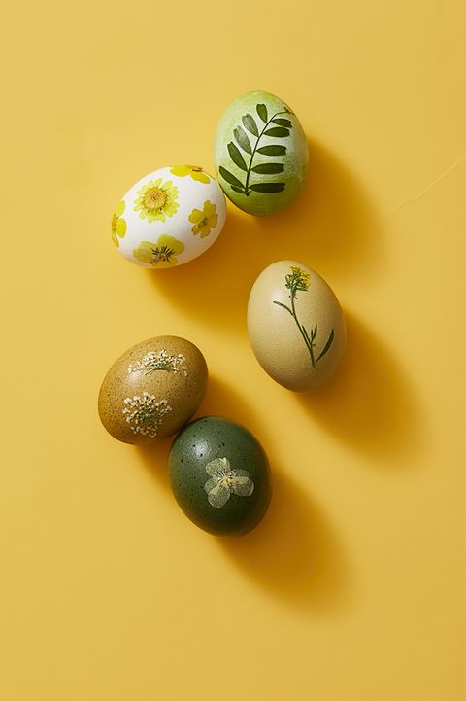  Can you make one like the odd egg?
Maths:  Session 1 and Activity:  https://whiterosemaths.com/homelearning/early-years/building-9-10-week-3/ | Maths:  Session 2 and Activity:  https://whiterosemaths.com/homelearning/early-years/building-9-10-week-3/ |  | Maths:  Session 3 and Activity:  https://whiterosemaths.com/homelearning/early-years/building-9-10-week-3/ | Maths:  Session 4 and Activity:  https://whiterosemaths.com/homelearning/early-years/building-9-10-week-3/ | Maths:  Session 5 and Activity:  https://whiterosemaths.com/homelearning/early-years/building-9-10-week-3/
**SEND YOUR PHOTOS TO YOUR CLASS TEACHER VIA THE EVIDENCE ME APP!*

