Phonics:  We are revising all the sounds we have covered so far (qu sh ch th ng ai ee igh oa oo ar)  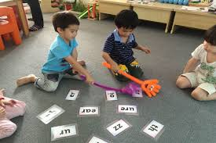  Play a game of splat the sound – write the letter sounds on cards and say the sound for chn to splat. | Phonics:  We are learning the new sound or and watch the video; https://www.youtube.com/watch?v=Kotny7AO-VY  Play Buried Treasure on phonics play with or words: https://www.phonicsplay.co.uk/resources/phase/2/buried-treasure  Read/write: He can see the horn. I was born in March. My sock is torn into bits. |  | Phonics:  We are learning the new sound nk (think stink pink). Watch Geraldine giraffe video: https://www.youtube.com/watch?v=7_c8RCjU8_g  Write these words in your phoneme frame: pink wink think sink link tank bank bunk  Read the yes/no questions:  Is a fork sharp? Will a fish forget things? Is a tail for wagging? Is a torch bright? | Phonics:  We are learning the new sound ur and watch the video: https://www.youtube.com/watch?v=N_eMHC35n24  Make an ur sound book with these words and pictures: surf fur burn curl turn turnip  Read/write the sentences:  My dad burps a lot! I can surf or sail a boat. My dog has fur on its tail. | Phonics:  Tricky word song:  https://www.youtube.com/watch?v=R087lYrRpgY  Reading and writing your high frequency word cards and introduce these words:  was my you be she he we me are them this they  Go on a word hunt in your house using these words!
Literacy:  Read 5 books from the Oxford Owl website.  (1 per day)  Write a shopping list for your Chinese meal/noodle making.  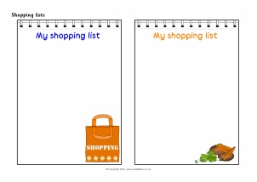 | The World/RE:  Have a look at the Chinese New Year festival and celebration.  This year is the year of the Ox – what is an ox?  Make a fact file/picture with facts about an Ox.  Pandas  Find out about pandas.  Paint a panda. Draw a panda.  https://www.youtube.com/watch?v=VNxx8jVEm3I  Look at bamboo:  https://www.youtube.com/watch?v=zf-smVBx5uY |  | Home Learning! 1/2/21  Theme: Castles, Knights and Dragons  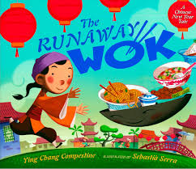  This week we will be learning about Chinese New Year. This is our focus story for the next few weeks; https://www.youtube.com/watch?v=Z6EduahxEMY |  | Literacy:  Share the story – The Runaway Wok (see video link).  https://www.youtube.com/watch?v=Z6EduahxEMY  Can you make a story map/road for the story?  (See attached story below)
Physical Development:  Make your own noodle dish or stir fry; https://www.bbc.co.uk/food/recipes/easy_chow_mein_for_kids_81406  Practice your cutting skills and scissor handling.  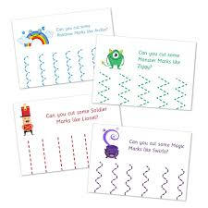  Make some pattern sheets to cut on and around. |  | WELL-BEING WEDNESDAY  We would like you and your children to focus on your well-being today! Here are a few ideas of things you could do:  - Senses walk – on your daily walk spot 3 things you can hear, smell, see and feel.  - Muddy madness! – Splash in puddles, roll down hills and get messy in the local park or field!  - Laughter therapy – have a go at some laughing Yoga sessions!  - Play, play and more play! Spend the day playing with your children – hide all devices and play games – let the children lead!  - Turn off screens and put down your phones and enjoy being with each other! |  | Art and Design:  Make a Chinese New Year lantern; https://www.youtube.com/watch?v=CeZKYGmuZn0  Make an Ox art piece.  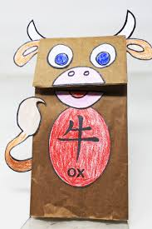  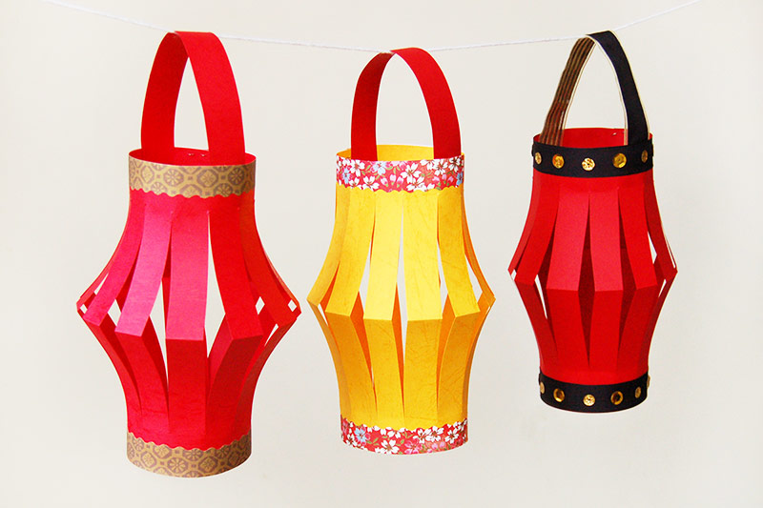
Maths:  Session 1 and Activity:  https://whiterosemaths.com/homelearning/early-years/growing-6-7-8-week-2/ | Maths:  Session 2 and Activity:  https://whiterosemaths.com/homelearning/early-years/growing-6-7-8-week-2/ |  | Maths:  Session 3 and Activity:  https://whiterosemaths.com/homelearning/early-years/growing-6-7-8-week-2/ | Maths:  Session 4 and Activity:  https://whiterosemaths.com/homelearning/early-years/growing-6-7-8-week-2/ | Maths:  Session 5 and Activity:  https://whiterosemaths.com/homelearning/early-years/growing-6-7-8-week-2/
**SEND YOUR PHOTOS TO YOUR CLASS TEACHER VIA THE EVIDENCE ME APP!*

The Runaway Wok Story (simplified version for retelling)

Once upon a time a poor couple who sent their son Ming to the market. Swap these eggs for rice Mummy Zhang said.
Ming ran to the market and he saw a man.
I will give you some eggs if you take this wok.
The wok was magic and could sing. Ming took it back to his house.
Mummy Zhang was not happy – she didn’t want a silly old wok!
Suddenly it rolled off the table and out of the door.
It went to see the rich man’s wife and sat on the table.
She filled it with delicious food.
And the wok ran back to Ming’s house.
Then it went to see the rich man’s son and sat on the table. The son put all his toys in the wok.
The wok ran back to Ming’s house.
After that the wok went to see the rich man and sat on the table. The man put all his coins in the wok.
The wok ran back to Ming’s house.
Mummy Zhang and Daddy Zhang were so happy.
They had food, toys and coins – they had the best CNY feast ever all because of the runaway wok!
The end.

