Phonics:  Geraldine Giraffe teaches the qu sound: https://www.youtube.com/watch?v=mYGGk0MH_xQ  Read/sound talk words: quack quit quiz quad quaff liquid quick  Read/write: Can a duck quack? Can a hen peck? The quiz is on. | Phonics:  Geraldine Giraffe teaches the sh sound: https://www.youtube.com/watch?v=nx2Tf9TE1bc  Play buried treasure game (real words go in the chest and nonsense words go in the trash)  Words: ship shop shell fish cash bash rush bush gush kish lish  Read caption: The shop has no fish. |  | Phonics:  ICT games blending bingo:  https://www.ictgames.com/mobilePage/bingoOriginal/index.html  Play the bingo game and write down words for chn to cross off their boards. Choose any of the phase 2/3 sounds previously covered. | Phonics:  Geraldine Giraffe teaches the ch sound: https://www.youtube.com/watch?v=OyrYDitif1o  Read/sound talk words: chin chip chick chill rich such  Read/write: We can be rich.  He has fish and chips. | Phonics:  Alphabet song and letter name practice: https://www.youtube.com/watch?v=XC6wQQHo8uU  Write ‘I can’ sentences.  I can hop.  I can run.  I can kick.
Literacy:  Read 5 books from the Oxford Owl website. (1 per day)  Create characters/puppets from the story ‘The Foggy Foggy Forest’ and retell familiar stories.  https://www.youtube.com/watch?v=SjnNBoRZTZE | The world:  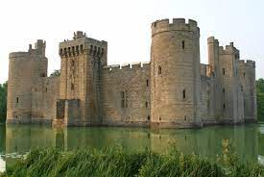  Look at and explore different castles online – what are the features of castles? Do they all look the same? What are they made from? | 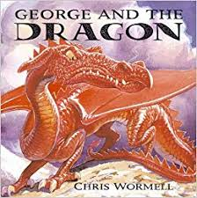  Home Learning! 5/1/21  Theme: Castles, Knights and Dragons  Have a look at our main story this half term-https://www.youtube.com/watch?v=IA9nAvl8uuw |  |  | Literacy:  Write some sentences about your Christmas holidays.  Use this sentence starter;  I went…
Physical Development:  Go on a winter walk and take photos of weather/seasonal changes. Describe them.  Travel in different ways e.g. skipping, hopping, jumping etc. |  |  |  | 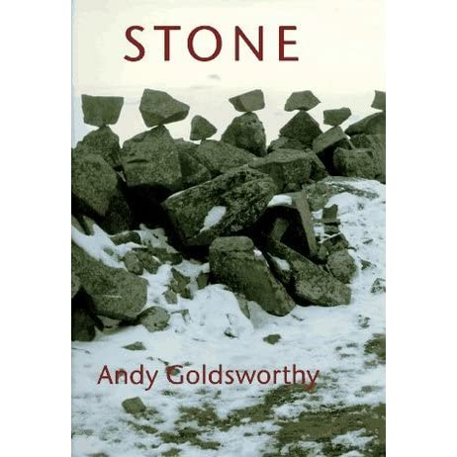  Art and Design:  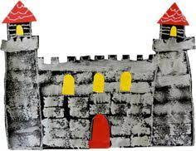  - Look at Andy Goldsworthy stone art – can you create a sculpture with stone/rock or pebbles? https://www.redtedart.com/kids-get-arty-andy-goldsworthy/  - Can you print a castle picture or design?
Maths:  Session 1 and Activity:  https://whiterosemaths.com/homelearning/early-years/alive-in-5-week-1/ | Maths:  Session 2 and Activity:  https://whiterosemaths.com/homelearning/early-years/alive-in-5-week-1/ |  | Maths:  Session 3 and Activity:  https://whiterosemaths.com/homelearning/early-years/alive-in-5-week-1/ | Maths:  Session 4 and Activity:  https://whiterosemaths.com/homelearning/early-years/alive-in-5-week-1/ | Maths:  Session 5 and Activity:  https://whiterosemaths.com/homelearning/early-years/alive-in-5-week-1/
**SEND YOUR PHOTOS TO YOUR CLASS TEACHER VIA THE EVIDENCE ME APP!*

