**Year 1 Long Term Overview**

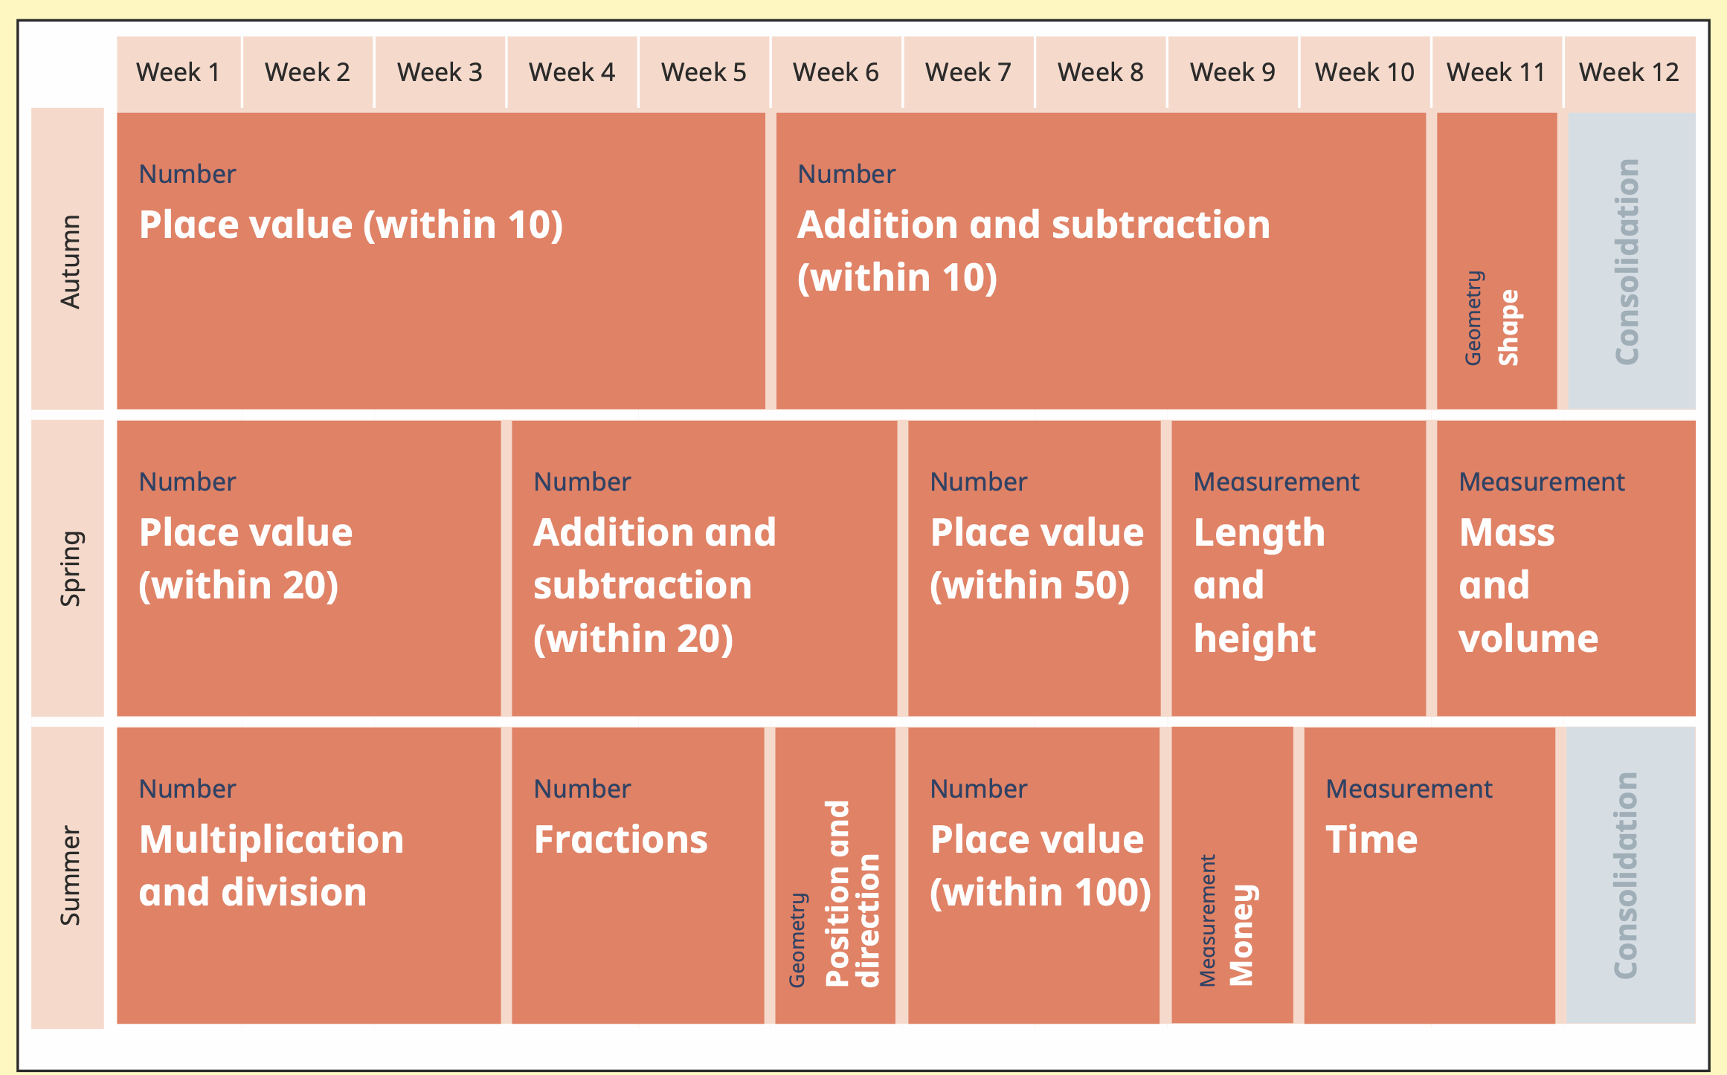

**Year 2 Long Term Overview**

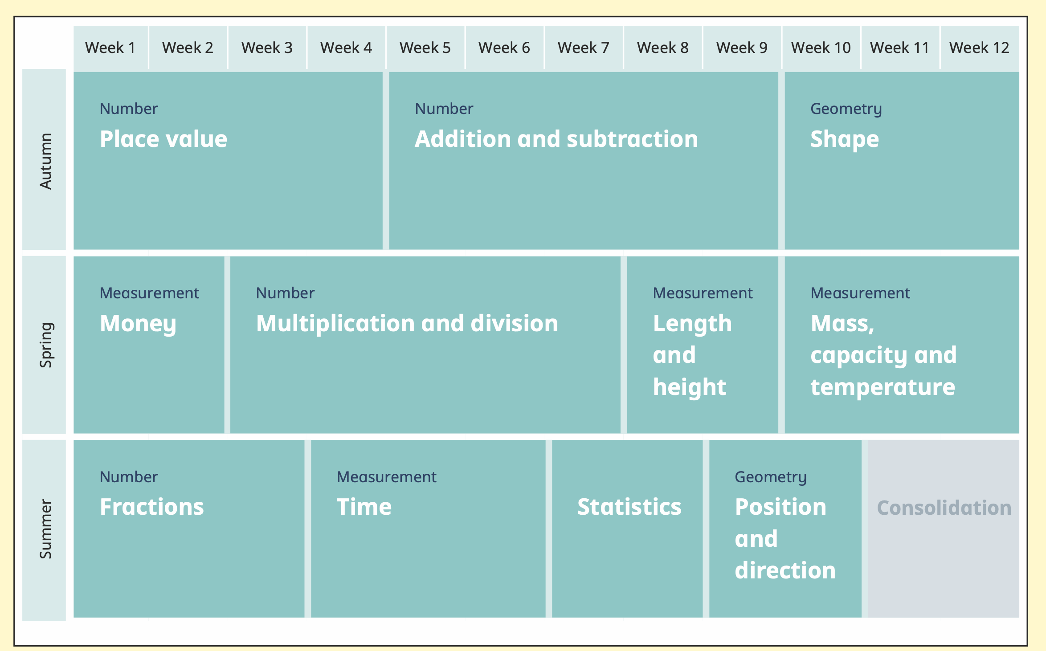

**Year 3 Long Term Overview**

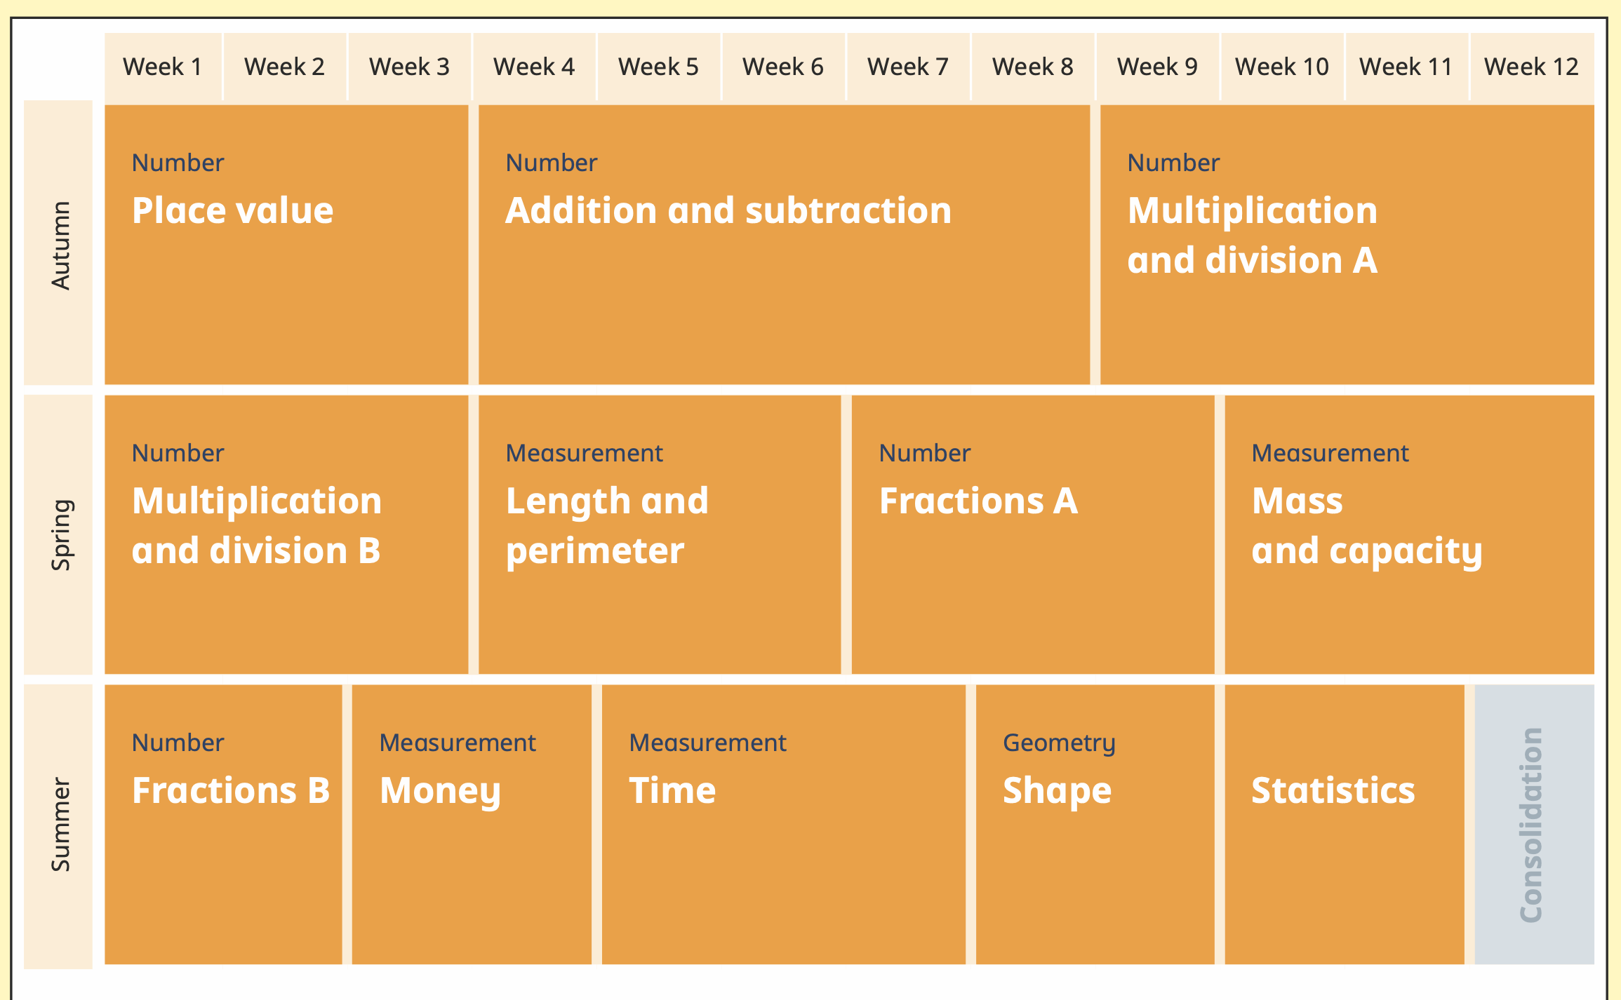

**Year 4 Long Term Overview**

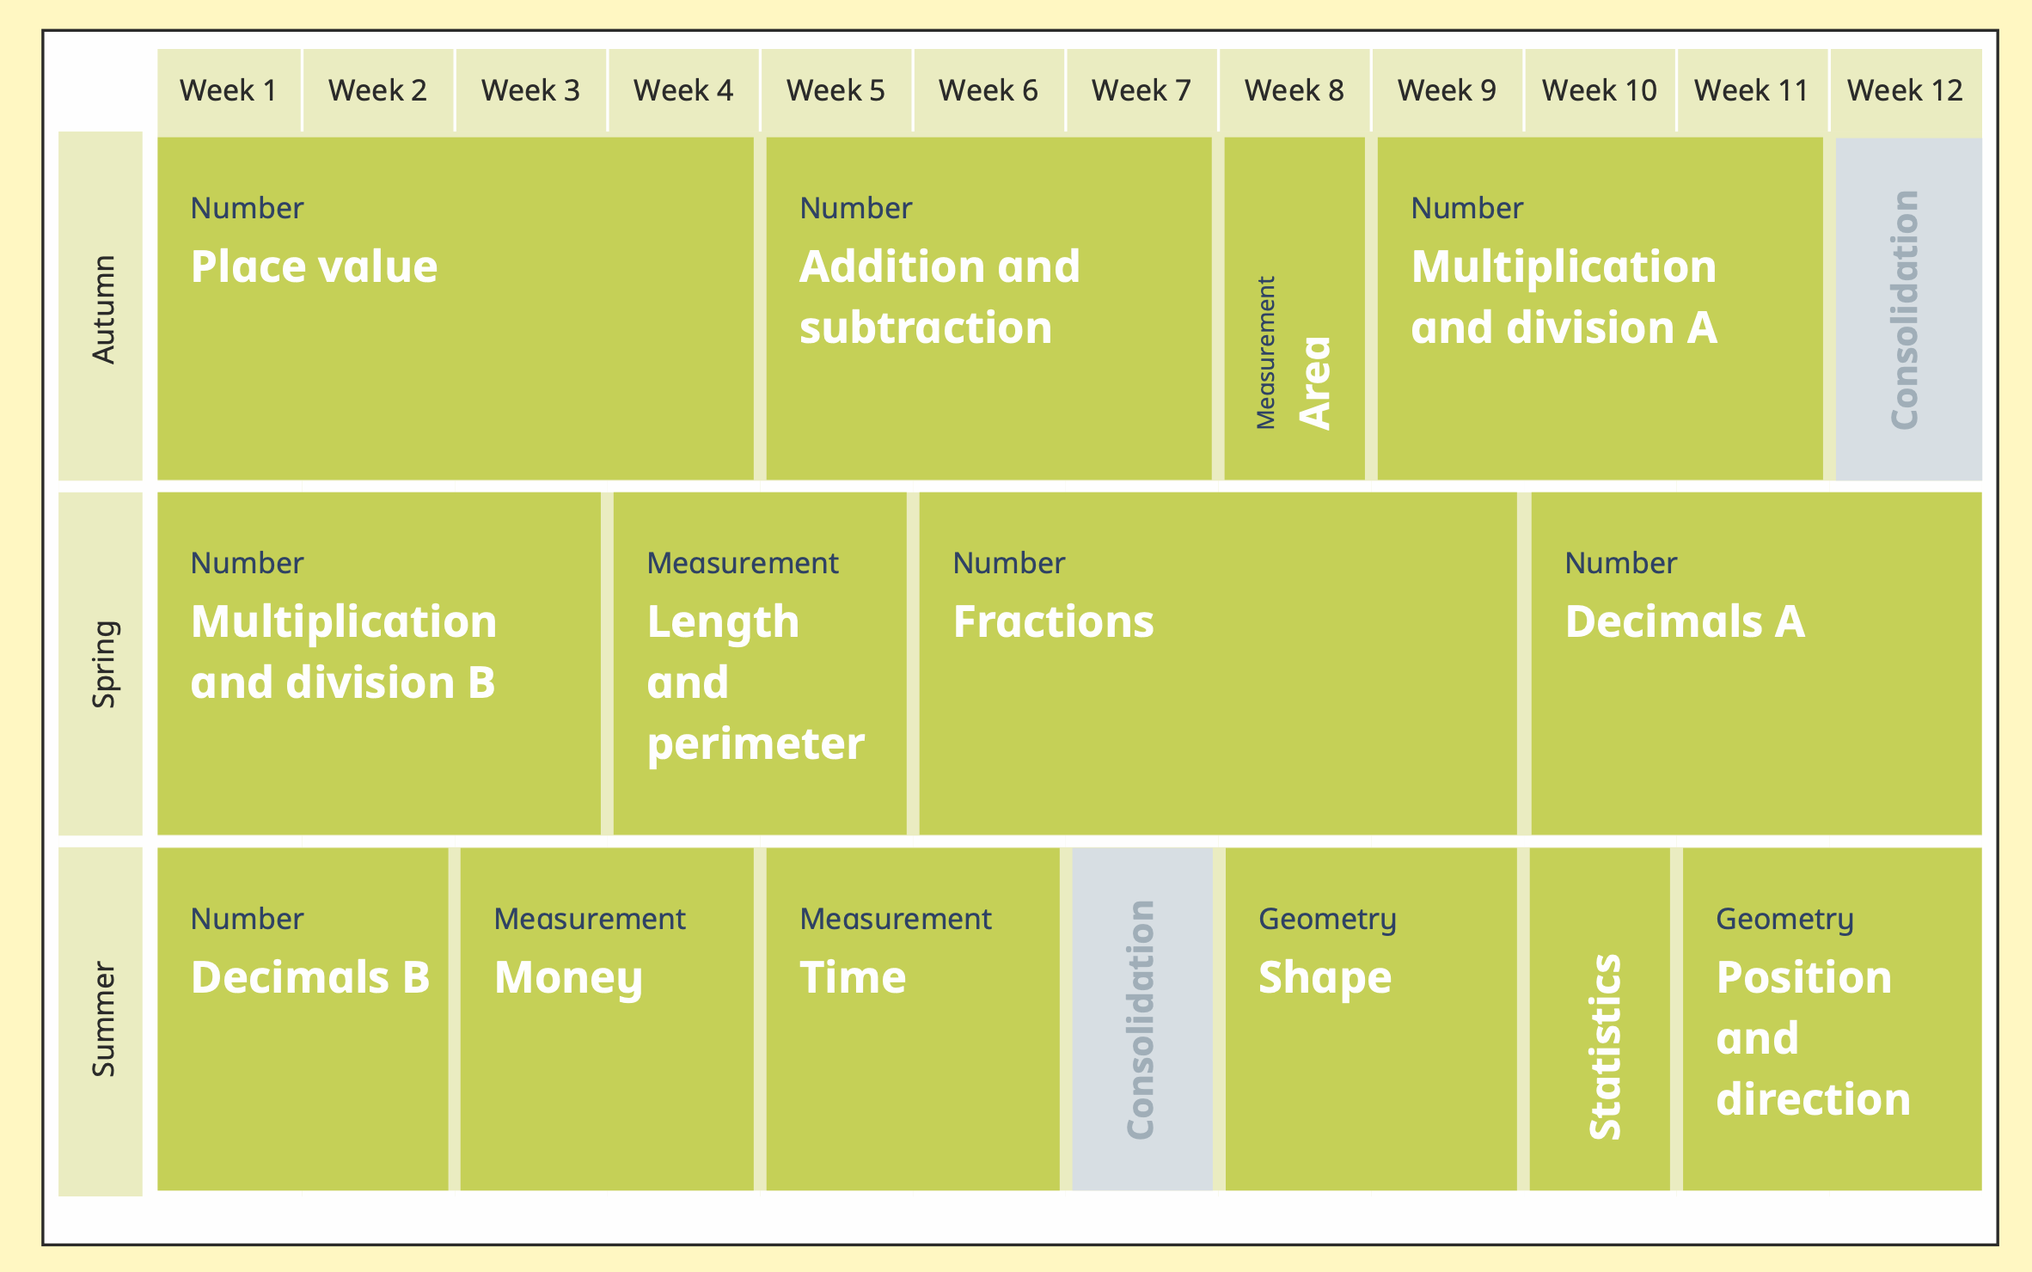

**Year 5 Long Term Overview**

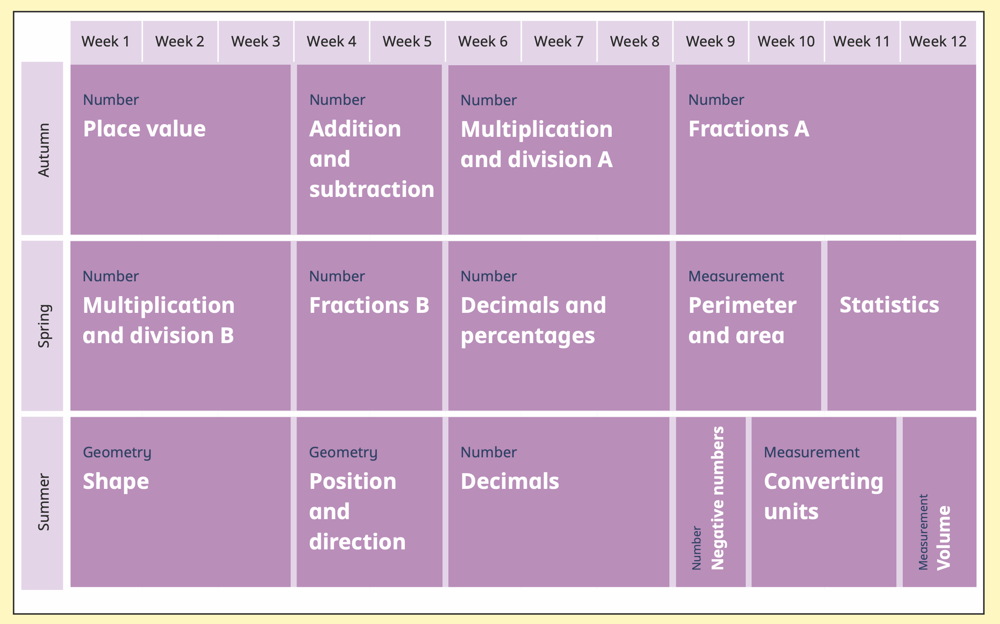

**Year 6 Long Term Overview**

