Phonics:  We are revising all the sounds we have previously covered.  Play picnic and pluto game on phonics play: https://www.phonicsplay.co.uk/  Re-order and write sentences:  The fork is sharp.  Can you hear the cow in the barn?  Fish and chips in a dish. | Phonics:  We are practicing reading and writing our tricky words.  Play a bingo game with tricky words: he she we me be was you they all are my her  Choose 4 and make a board, find words hidden in your house and cross them off your boards. Shout bingo when you have found them all!  See tricky word game: https://epicphonics.com/games/play/free-penalty-shootout-tricky-words-game |  | Phonics:  Play games on Star fall: https://www.starfall.com/h/ltr-classic/  Try Forest Phonics games: Can you build the words?  http://www.ictgames.com/mobilePage/forestPhonics/index.html | Phonics:  We are revising all the sounds we have previously covered.  Sorting sounds into trigraphs, digraphs and single phonemes.  Write sounds on cards/pieces of paper and sort them into the 3 groups.  Which sounds do the chn know?  Can they think of a word with these sounds? | Phonics:  We are revising all the sounds we have previously covered.  Play the word spin game on word wall –  Re-order and write sentences:  Did the sheep get to the dark lair?  Is the church on top of the hill?
Literacy:  Learn the story map for Jack and the beanstalk – see below.  Perform this with actions and role play the different characters.  Here is an example of a video of the story; https://www.youtube.com/watch?v=rKB1_wBueFM | The World/RE:  Discuss special times with your child. What is a special time for you?  What can grow?  Look at beans and seeds. What do they need to grow?  Look at this song; https://www.youtube.com/watch?v=hCqymjSP-BE |  | Home Learning! 1/3/21  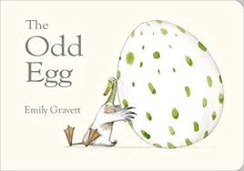  Theme: New Life!  Our main book this half term is ‘The Odd Egg’ https://www.youtube.com/watch?v=8LKoji2i7Cw |  | Literacy:  Have a go at some of Stick Man reading sessions; see links below. They focus on children’s comprehension skills when reading.  Session 1: https://www.youtube.com/watch?v=lEpN6O2ytuQ&feature=youtu.be  Session 2: https://www.youtube.com/watch?v=CRcj_O1L1ZI&feature=youtu.be  Session 3: https://www.youtube.com/watch?v=3tIsc5kxnZY&feature=youtu.be
Physical Development:  Play the ‘bean game’ – move around your house or garden or park using different actions for different beans. E.g., runner bean, jellybean, jumping bean, broad bean etc.  WORLD BOOK DAY! 4/3/21  - Try some ‘extreme reading’ and read a book in extreme places e.g. in the bath, under the table, on top of a cupboard etc. the more extreme the better!  - Dress up as your favorite book character and go on a walk dressed as this character!  - Make your own story setting using different props in your house e.g. a castle with bricks, a forest with sticks and leaves. |  | WELL-BEING WEDNESDAY  We would like you and your children to focus on your well-being today! Here are a few ideas of things you could do:  - Make some fruity drinks or mock tails! Have a look on here for some recipes – https://www.bbcgoodfood.com/recipes/collection/kids-mocktail-recipes  - Talk with your child about returning to school – how are they feeling? Share the ‘Worrysaurus’ story to reassure any worries they might have. https://www.youtube.com/watch?v=WklyyxNKAL0  - Make a breathing cup – try and practice breathing exercises and mindfulness. https://www.allkidsnetwork.com/crafts/fantasy/dragon-cup-craft.asp |  | 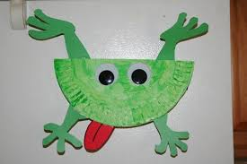  Art and Design:  Make some frog pictures.  Use junk and boxes to make a model – can you name the 3D shapes you have used?  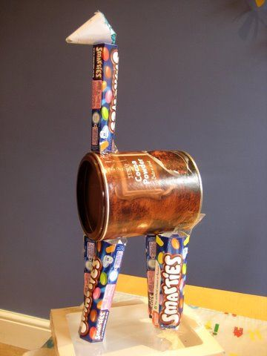  Can you describe the 3D shapes?
Maths:  Lesson 1:  https://classroom.thenational.academy/units/shape-and-pattern-dba1 | Maths:  Lesson 2:  https://classroom.thenational.academy/units/shape-and-pattern-dba1 |  | Maths:  Lesson 3:  https://classroom.thenational.academy/units/shape-and-pattern-dba1 | Maths:  Lesson 4:  https://classroom.thenational.academy/units/shape-and-pattern-dba1 | Maths:  Lesson 5:  https://classroom.thenational.academy/units/shape-and-pattern-dba1
**SEND YOUR PHOTOS TO YOUR CLASS TEACHER VIA THE EVIDENCE ME APP!*

Jack and the Beanstalk
Once upon a time there was a poor boy called Jack who lived with his mother in a ramshackle house. One day his mother said “Go to the market and sell the cow.
So Jack walked and he walked and he walked until he got to the market. He sold the cow but unfortunately all he got was beans, big brown beans.
When he got home he put the beans on the table. His mother was furious and she threw the beans out of the window. The very next day the beans had grown into a towering beanstalk.
So Jack decided to climb the beanstalk. He climbed and he climbed and he climbed.
When he got to the clouds he saw a huge castle.
He walked and he walked and he walked until he got to the castle.
First he pushed open the huge door. Next he crept in.
Then he saw his mother’s old hen that laid golden eggs. As quick as a flash he grabbed the hen. Suddenly he heard…….
“FIE FI FO FUM” and a huge giant came into the room. Jack ran and he ran and he ran and raced down the towering beanstalk. Unfortunately, the huge giant chased after him.
Jack grabbed an axe and he chopped and he chopped and he chopped until the towering beanstalk came tumbling down.
The huge giant tumbled to the ground and that was the end of him. Jack and his mother and the hen that laid golden eggs lived happily ever after.
The End.

