Phonics:  We are revising all the sounds we have covered so far (qu sh ch th ng ai ee igh oa oo ar)  Play the jolly phonics song and do the actions; https://www.dailymotion.com/video/xuidg1  Read/write: I go to the moon in a boat.  (You could write this and cut it up and try and order it!) | Phonics:  We are revising all the sounds we have covered so far. (qu sh ch th ng ai ee igh oa oo ar)  Play the jolly phonics song and do the actions; https://www.dailymotion.com/video/xuidg1  Read/write: Is a fork sharp? Is corn red? Is a torch bright? | Phonics:  Tricky word song:  https://www.youtube.com/watch?v=R087lYrRpgY  Reading and writing your high frequency word cards and introduce these words:  was my you be she he we me  Go on a word hunt in your house using these words! | Phonics:  We are revising all the sounds we have covered so far. (qu sh ch th ng ai ee igh oa oo ar)  Play Buried Treasure on phonics play: https://www.phonicsplay.co.uk/resources/phase/2/buried-treasure  Read/write: Is it light at night? Can a fox sail? Can fish weep? | Phonics:  We are revising all the sounds we have covered so far. (qu sh ch th ng ai ee igh oa oo ar)  Play the jolly phonics song and do the actions; https://www.dailymotion.com/video/xuidg1  Read/write in your phoneme frames: goat sheep night jacket wait chip moon
Literacy:  Read 5 books from the Oxford Owl website. (1 per day)  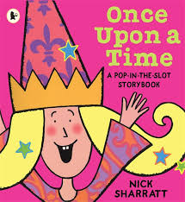  Make your own fairytale story stones to create your own stories with.  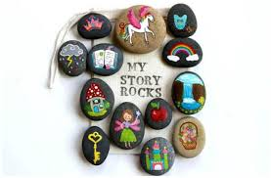 | The World/RE:  It has been raining lots at the moment.  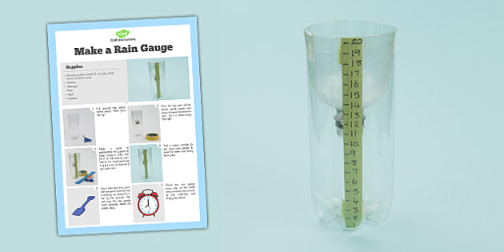  Can you make a rain gauge in your garden/outdoor area to catch and measure the rainfall over a week?  RE: Listen and talk about a bible story – here is a link to Jonah and the whale; https://www.youtube.com/watch?v=WOSadLyqshg | Home Learning! 25/1/21  Theme: Castles, Knights and Dragons  We are exploring fairytale stories this week.  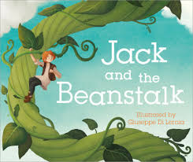  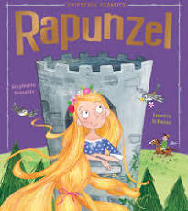  What fairytales do you know? |  | Literacy:  What is a fairytale?  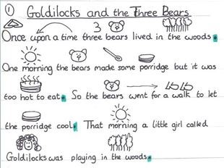  Can you make a story map and retell Goldilocks and the 3 bear’s story?
Physical Development:  Try some Joe Wicks PE sessions this week: https://www.youtube.com/watch?v=hnOtrnh80hs  Make some fairy dough! This is great for fine motor skills!  https://laughingkidslearn.com/fairy-playdough-recipe/ |  |  | 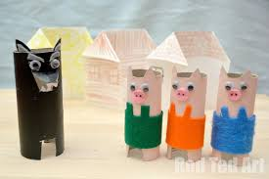  Art and Design: Make some fairytale masks and props for your stories using junk modelling.  How can you join your materials?  Can you use different methods of joining and sticking?
Maths:  Session 1 and Activity:  https://whiterosemaths.com/homelearning/early-years/growing-6-7-8/ | Maths:  Session 2 and Activity:  https://whiterosemaths.com/homelearning/early-years/growing-6-7-8/ | Maths:  Session 3 and Activity:  https://whiterosemaths.com/homelearning/early-years/growing-6-7-8/ | Maths:  Session 4 and Activity:  https://whiterosemaths.com/homelearning/early-years/growing-6-7-8/ | Maths:  Session 5 and Activity:  https://whiterosemaths.com/homelearning/early-years/growing-6-7-8/
**SEND YOUR PHOTOS TO YOUR CLASS TEACHER VIA THE EVIDENCE ME APP!*

