Phonics:  Geraldine Giraffe teaches the igh sound: https://www.youtube.com/watch?v=OYCR2RZ4ZYY  Read/sound talk words: night light tight might fight high sigh  Read/write: Is it light at night? Will it rain tonight? | Phonics:  Geraldine Giraffe teaches the oa sound: https://www.youtube.com/watch?v=KCJyHN0IFE8  Play obb and bob game with oa words on phonics play: https://www.phonicsplay.co.uk/resources/phase/2/picnic-on-pluto  Write the sentence: The boat has a sail. |  | Phonics:  Alphablocks video on the oo sounds:  https://www.youtube.com/watch?v=0N0syRgDJ20  Sorting game with oo word cards: moon zoom boom book cool look took hook  Read/write: This book is cool. | Phonics:  Geraldine Giraffe teaches the ar sound: https://www.youtube.com/watch?v=QXBQDsgRuMo  Read/sound talk words: car far tart park lark harp bark dark shark  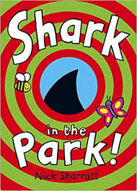  Read/share the shark in the park story: https://kidsclubenglish.com/story-resource-page/shark-in-the-park-3/?cn-reloaded=1  How many ar words can you find? | Phonics:  Tricky word song:  https://www.youtube.com/watch?v=R087lYrRpgY  Reading and writing your high frequency word cards and introduce these words:  was my you  Go on a word hunt in your house using these words!
Literacy:  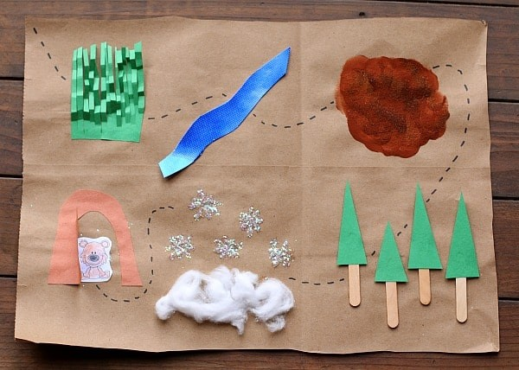  Read 5 books from the Oxford Owl website. (1 per day)  Make a story road to help retell the story: change the bear to a dragon!  “We’re going on a dragon hunt, we’re going to trap a big one, and we’re not scared!” | The World/RE:  Explore and talk about other special stories and books from different faiths. What is a ‘holy book’?  What does this mean?  Use this link; https://www.twinkl.co.uk/resource/t2-r-037-relgious-stories-and-beliefs-powerpoint | Home Learning! 18/1/21  Theme: Castles, Knights and Dragons  Here are some other dragon stories you might want to look at;  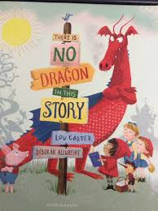  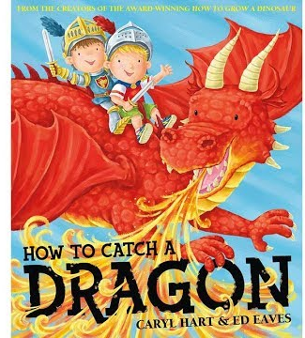  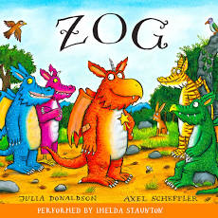 |  |  | Literacy:  Make some sound books! Draw some pictures and write some words that have that letter sound in them!  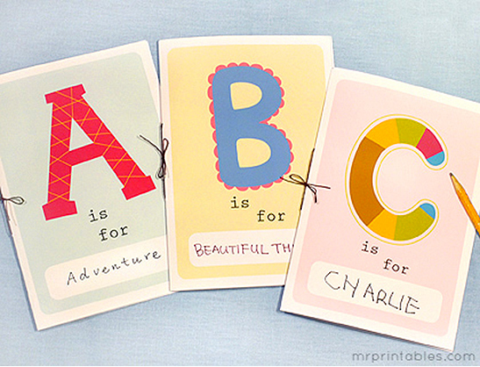
Physical Development:  Make a dragon den or cave in your house or garden – if the weather is okay! Use sheets, boxes, furniture – anything you can find!  Try some Joe Wicks PE sessions this week: https://www.youtube.com/watch?v=hnOtrnh80hs |  |  |  | 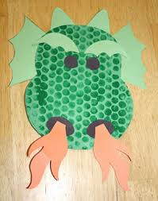  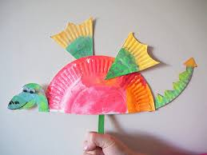  Art and Design:  Make your own dragon pictures using different media and materials.
Maths:  Session 1 and Activity:  https://whiterosemaths.com/homelearning/early-years/alive-in-5-week-3/ | Maths:  Session 2 and Activity:  https://whiterosemaths.com/homelearning/early-years/alive-in-5-week-3/ |  | Maths:  Session 3 and Activity:  https://whiterosemaths.com/homelearning/early-years/alive-in-5-week-3/ | Maths:  Session 4 and Activity:  https://whiterosemaths.com/homelearning/early-years/alive-in-5-week-3/ | Maths:  Session 5 and Activity:  https://whiterosemaths.com/homelearning/early-years/alive-in-5-week-3/
**SEND YOUR PHOTOS TO YOUR CLASS TEACHER VIA THE EVIDENCE ME APP!*

