Phonics:  Geraldine Giraffe teaches the th sound: https://www.youtube.com/watch?v=6U354eD-hgQ  Read/sound talk words: this that thin thick moth path  Read/write: The thin man is on the path. | Phonics:  Geraldine Giraffe teaches the ng sound: https://www.youtube.com/watch?v=vQshNmncnBs  Write the words below in your phoneme frames.  Words: ring sing ping song pong ding king  Read caption: The king sings a song. |  | Phonics:  Geraldine Giraffe teaches the ai sound: https://www.youtube.com/watch?v=LnXaN-CvR9s  Play buried treasure on phonics play using ai words: https://www.phonicsplay.co.uk/resources/phase/2/buried-treasure | Phonics:  Geraldine Giraffe teaches the ee sound: https://www.youtube.com/watch?v=qfM7Hz7US0U  Read/sound talk words: bee see meet feet feel weep deep  Read/write: I can see the king. I can sing a song. I am in the deep pond. | Phonics:  Tricky word song:  https://www.youtube.com/watch?v=R087lYrRpgY  Reading and writing your high frequency word cards and introduce these words: we be me he she  Go on a word hunt in your house using these words!
Literacy:  Read 5 books from the Oxford Owl website. (1 per day)  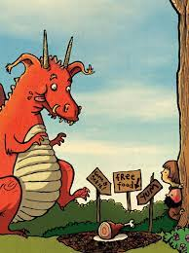  Recite/retell instructions about how to catch a dragon. See text map below. Use actions for each instruction! | The world:  Look at snow and mountains – where in the world has snowy mountains like the ones in our main story? Create some snowy mountain scenes. https://www.youtube.com/watch?v=uC-USAB530A  RE: Favorite stories and special books – what is your favorite story? Why? Record a video talking about your book. | 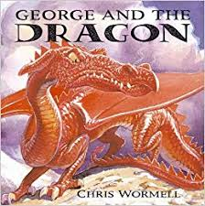  Home Learning! 11/1/21  Theme: Castles, Knights and Dragons  Have a look at our main story this half term-  https://www.youtube.com/watch?v=IA9nAvl8uuw |  |  | Literacy:  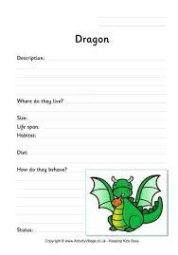  Create a dragon fact file. What do dragons look like? How do they move? What do they eat?
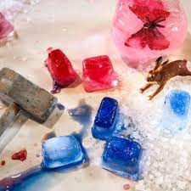  Physical Development:  Freeze some objects in ice and try and get them out using different tools in your house e.g. tweezers, spoons, forks, spatulas, hammers etc. What tool worked best?  Build a trap outdoors to catch a dragon! Follow our instruction text map! |  |  |  | 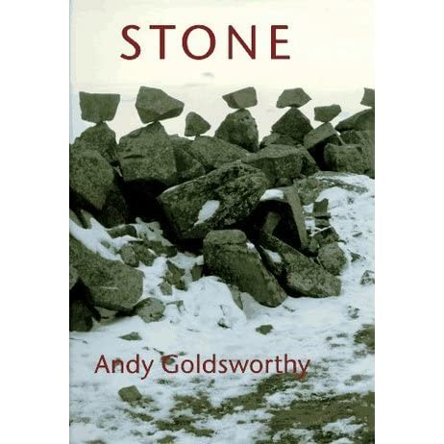  Art and Design:  Continue to look at Andy Goldsworthy stone art – can you create a sculpture with stone/rock or pebbles? https://www.redtedart.com/kids-get-arty-andy-goldsworthy/  Ricky the Rock that rolled – find some different types of rocks in your garden or on your walks. https://www.youtube.com/watch?v=rQqI5jPGFYg
Maths:  Session 1 and Activity:  https://whiterosemaths.com/homelearning/early-years/alive-in-5-week-2/ | Maths:  Session 2 and Activity:  https://whiterosemaths.com/homelearning/early-years/alive-in-5-week-2/ |  | Maths:  Session 3 and Activity:  https://whiterosemaths.com/homelearning/early-years/alive-in-5-week-2/ | Maths:  Session 4 and Activity:  https://whiterosemaths.com/homelearning/early-years/alive-in-5-week-2/ | Maths:  Session 5 and Activity:  https://whiterosemaths.com/homelearning/early-years/alive-in-5-week-2/
**SEND YOUR PHOTOS TO YOUR CLASS TEACHER VIA THE EVIDENCE ME APP!*

 | 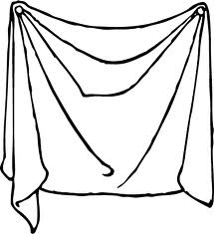 | 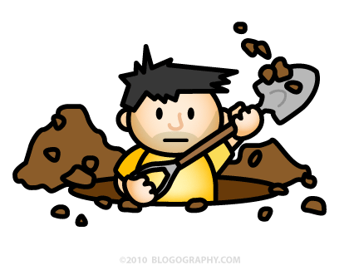
How to trap a dragon | You will need: a spade, a brown sheet, some leaves and sticks, plus a large lump of tasty meat. | First, dig a deep pit. | Next cover the pit with a brown sheet.
After that, scatter on the leaves and sticks. | Finally place the large lump of meat on top. | Now tiptoe behind a tree and wait. | The dragon will smell the meat and fall into the pit!

