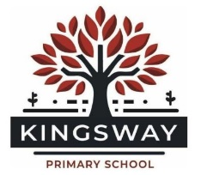
Kingsway Park, Davyhulme, Manchester, M41 0SP
Telephone: 0161 748 1867
Headteacher: Miss Kate Baskeyfield

30 Hours Free Childcare – Information for Childcare Provider

Please complete the information below and return this form to school as soon as possible.

We are required to perform a termly check that your 30 hour childcare code is still valid and that your circumstances have not changed. Completion of this form acts as consent for us to carry out these checks whilst your child is receiving childcare at our Nursery.

Details:
Name of Child: |  | Ethnicity:
Date of Birth: |  | Gender:
Address:

Parent’s Forename: | Parent’s Surname:
Parent’s DOB | Parent’s NI Number:
Telephone No. | Childcare Code:

Unfortunately, we cannot offer your child 30 hours free childcare without your 11 digit Eligibility Code.

Childcare will be offered between the hours of 8:45 a.m. and 3:15 p.m. Monday to Friday. Parents must provide their child with a packed lunch.

Whilst performing the quarterly code check we would like to check if your child is eligible for Early Years Pupil Premium. Please indicate if you give permission for us to carry out this check Yes / No (Please circle your answer)

Signed………………………………………………………………………..…. Date ……………………………..……………

