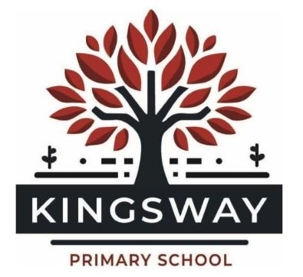
Kingsway Park, Davyhulme, Manchester, M41 0SP
Telephone: 0161 748 1867
Headteacher: Miss Kate Baskeyfield
Registration for Early Years Childcare Places

Dear Parents

Before your child starts in the Nursery at Kingsway Primary School you will need to register for your free childcare place.

Registration should be completed for both 15 hours childcare (which every child is entitled to) and 30 hours childcare (which is based on both parents working/family income).

All Parents/Carers

Please click the following link to apply for 15 hours free childcare https://educationhub.blog.gov.uk/2023/01/02/when-apply-for-15-hours-free-childcare/

Please email kingsway.admin@trafford.gov.uk once you have applied for your hours to secure
your place at our nursery.

Parents applying for 30 hours childcare

P
click Please click the following link to apply for 30 hours free childcare
https://www.gov.uk/apply-free-childcare-if-youre-working

Once you have confirmed your eligibility you will be given an 11 digit code. You should now
complete the 30 hour Childcare Check form attached and return it to Kingsway Primary School asap. (you can email this as a screenshot to Kingsway.admin@trafford.gov.uk

Please Note: Eligibility codes are checked every 3 months. You will be notified by HM Revenue &
Customs that they require confirmation that your circumstances have not changed. Please ensure
you confirm your circumstances to avoid funding being withdrawn.

If you have any questions, please contact Trafford Family Information Service

Telephone 0161 912 1050 Mon-Fri 8:30 am – 5:00 pm
Email FIS@trafford.gov.uk
Facebook www.facebook.com/TraffordFIS
Website www.trafforddirectory.co.uk

